PSAppDeployToolkit (PSADT)

The PSAppDeployToolkit (PSADT) is a PowerShell-based framework that simplifies application deployment for enterprises.

*Platform Value:*

1. Simplifies Complex Scripting
2. Consistent User Experience
3. Improved Deployment Success
4. Open-Source and Contributed

*Concepts:*

1. **ADTSession Object** – Stores user input and settings.
2. **Pre-defined Functions** – Built-in commands for install, check, close apps.
3. **Exit Codes** – Shows if install passed or failed.
4. **Deployment Structure** – Organized folders for clean setup.
5. **Deployment Modes** – Supports silent, interactive, or auto installs.

*Usage:*

* **Deploying Applications**
* **Scripting Deployment Logic**
* **Using Functions**
* **Running Scripts**
* **Utilizing ADTSession**

**PowerShell App Deployment Toolkit specific folder structure to organize deployment packages and their associated files.**

Toolkit

Examples

Files

SupportFiles

Deploy-Application.exe

Deploy-Application.ps1

Strings

Images

Configuration

Configuration Process

1. Download and Extract: Download the PSAppDeployToolkit and extract the zip file.

2. Locate Configuration File: Navigate to the Toolkit\AppDeployToolkit directory and find the AppDeployToolkitConfig.xml file.

3. Edit Configuration: Open the AppDeployToolkitConfig.xml file and customize it according to your needs.

● Toolkit Options: Configure general toolkit settings like required administrative rights, temporary file paths, and logging options.

● Banner, Logo & Icon Options: Customize the UI banner, logos, and icons.

● MSI Options: Configure logging options, log paths, and installation parameters for MSI installations. ● UI Options: Set general UI options like balloon notifications, script timeouts, and exit codes.

● UI Messages: Edit or add languages for the user interface.

*The PowerShell Application Deployment Toolkit (PSAppDeployToolkit) provides template scripts for application deployment. These scripts, like Deploy-Application.ps1, are designed to streamline the deployment process and ensure consistency across deployments.*

1. Understanding PSAppDeployToolkit and Templates
2. Using the Template Script (Deploy-Application.ps1)
3. Creating a New Deployment Using Templates:

Installation of power shell application deployment toolkit

Search -> PSApp Deployment ToolKit ->

[PSAppDeployToolkit Latest Release](https://github.com/PSAppDeployToolkit/PSAppDeployToolkit/releases/latest)

>[https://github.com/PSAppDeployToolkit/PSAppDeployToolkit/releases/download/4.0.6/PSAppDeployToolkit_Template_v4.zip->https://github.com/PSAppDeployToolkit/PSAppDeployToolkit/releases/download/4.0.6/PSAppDeployToolkit_Template_v3.zip](https://github.com/PSAppDeployToolkit/PSAppDeployToolkit/releases/download/4.0.6/PSAppDeployToolkit_Template_v4.zip-%3ehttps://github.com/PSAppDeployToolkit/PSAppDeployToolkit/releases/download/4.0.6/PSAppDeployToolkit_Template_v3.zip)

->Download it -> Extract in the folder inside download ->There are multiple version

Version 3

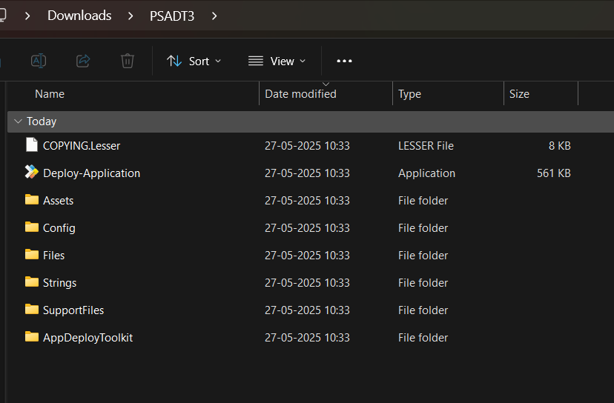

Version 4

